Приложение 1
Тексты, задания для учащихся.
Read the text and fill in the gaps with my/ her/ his/ our/ their
___(1) name is Ted. I’m 11. I have got a sister. ___(2) name is Jessy and there is a mess in ___(3) room. I have got two brothers. They are twins. ___(4) names are Bill and Tony. There are a lot of toys in ___(5) bedroom.

Read the text and fill in the gaps with my/ her/ his/ our/ their
___(1) name is Ted. I’m 11. I have got a sister. ___(2) name is Jessy and there is a mess in ___(3) room. I have got two brothers. They are twins. ___(4) names are Bill and Tony. There are a lot of toys in ___(5) bedroom.

Read the text and fill in the gaps with my/ her/ his/ our/ their
___(1) name is Ted. I’m 11. I have got a sister. ___(2) name is Jessy and there is a mess in ___(3) room. I have got two brothers. They are twins. ___(4) names are Bill and Tony. There are a lot of toys in ___(5) bedroom.

Read the text and fill in the gaps with my/ her/ his/ our/ their
___(1) name is Ted. I’m 11. I have got a sister. ___(2) name is Jessy and there is a mess in ___(3) room. I have got two brothers. They are twins. ___(4) names are Bill and Tony. There are a lot of toys in ___(5) bedroom.

Read the text and fill in the gaps with my/ her/ his/ our/ their
___(1) name is Ted. I’m 11. I have got a sister. ___(2) name is Jessy and there is a mess in ___(3) room. I have got two brothers. They are twins. ___(4) names are Bill and Tony. There are a lot of toys in ___(5) bedroom.

Match A-D with 1-5
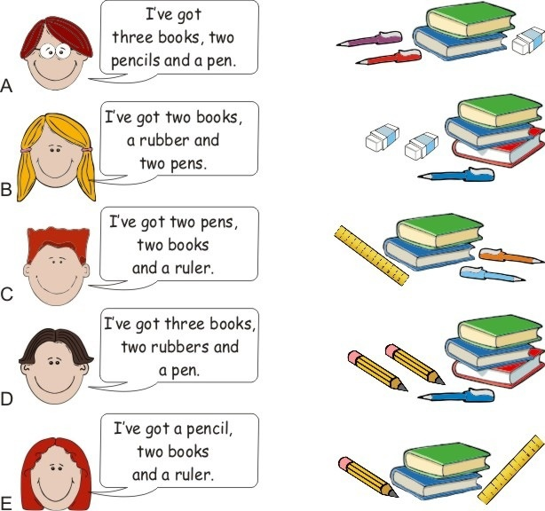
5
4
3
2
1

Match A-D with 1-5
5
4
3
2
1

Find and say where the rubber, pen, bag, books, pencil case are.
Use the prepositions and there is/are. Example: “There is a rubber on the chair”
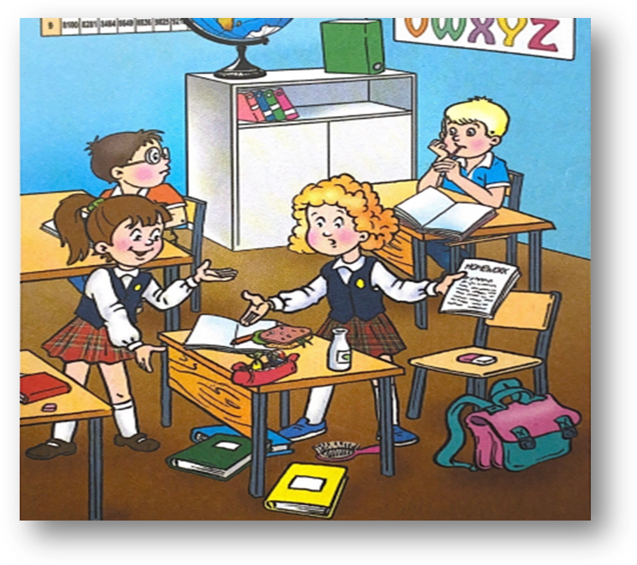
Find and say where the rubber, pen, bag, books, pencil case are.
Use the prepositions and there is/are. Example: “There is a rubber on the chair”
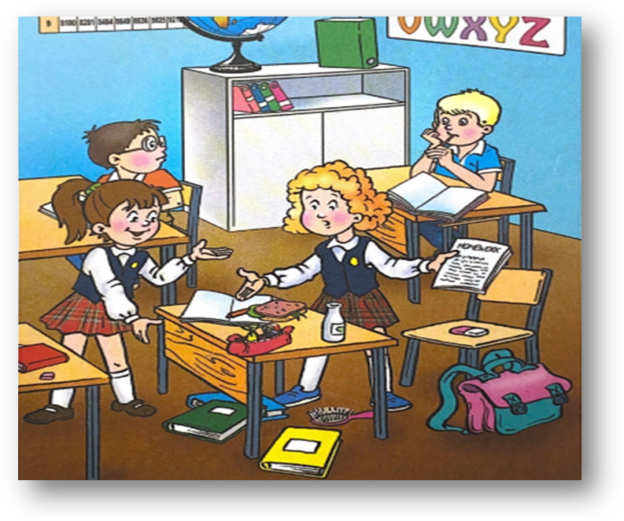

Find the words
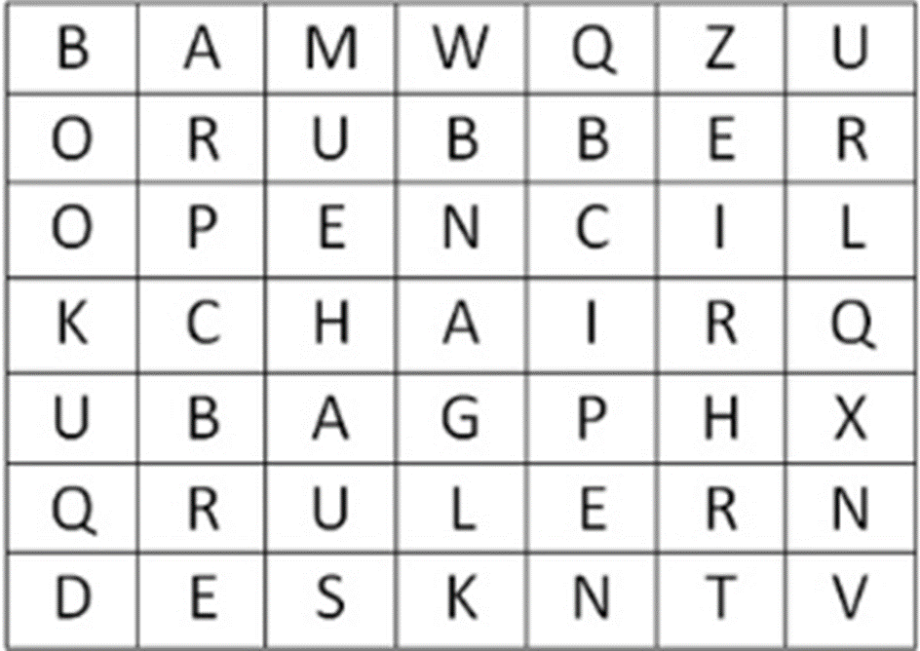

Find the words

Find as many places as you can and name them
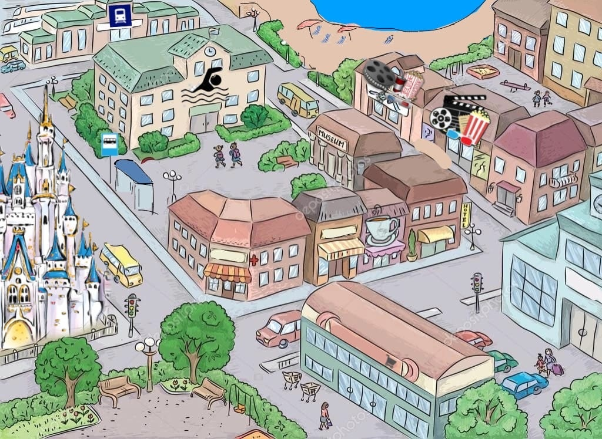
Find as many places as you can and name them

Solve the puzzle
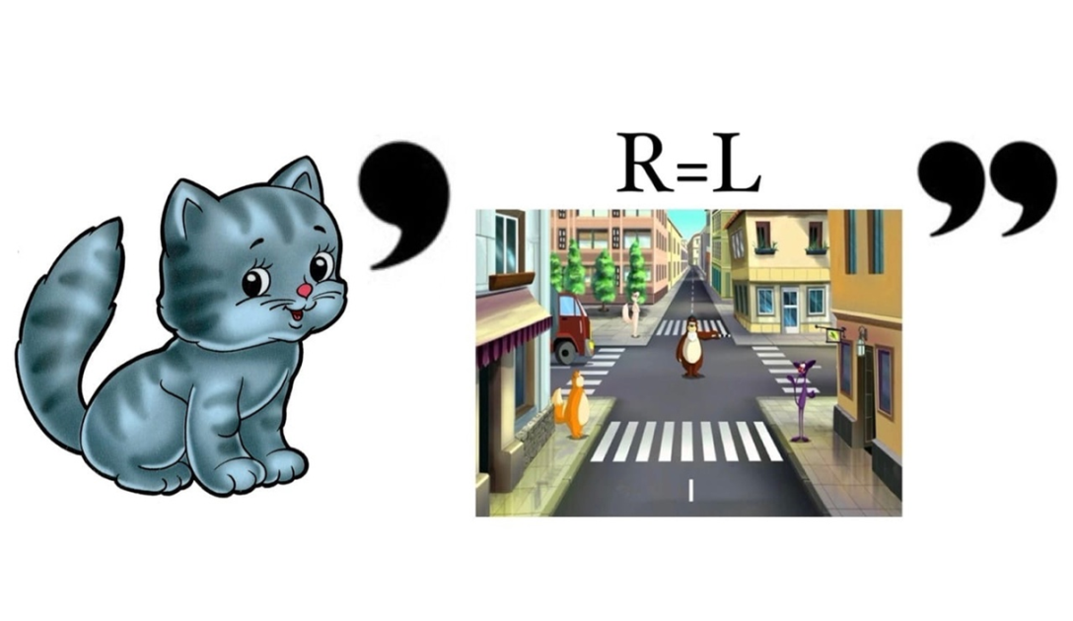
Solve the puzzle
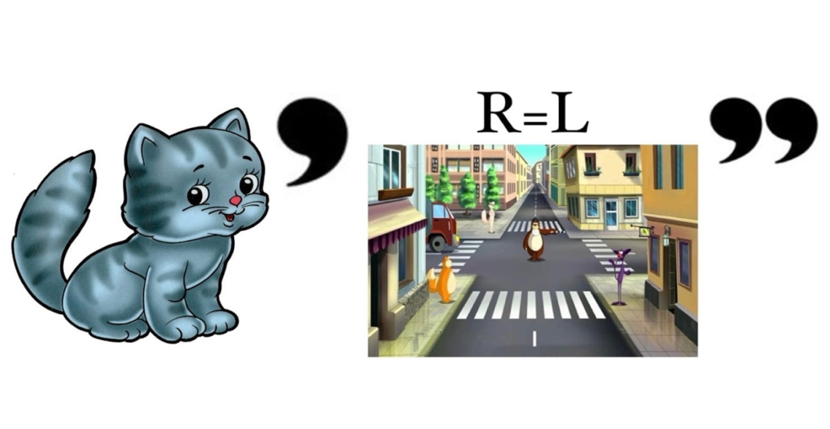
Solve the puzzle
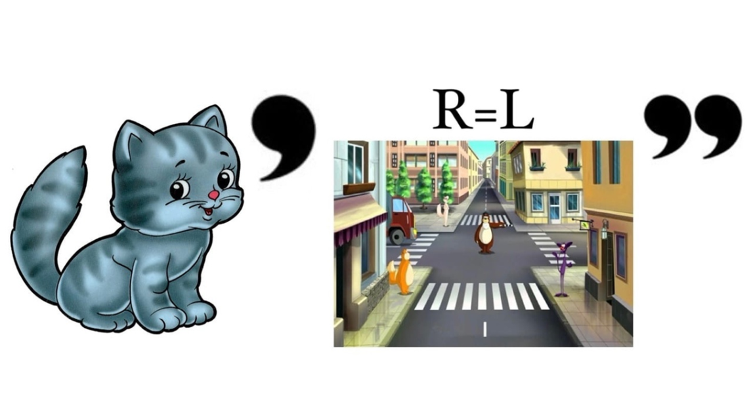

Complete the text with a/an, any
My town is great! There is …(1) big river and there is …(2) old bridge over it. There isn’t …(3) railway station, but there is …(4) big bus station. There are a lot of restaurants and there aren’t …(5) big supermarkets. What about your town? Are there …(6) museums?
Complete the text with a/an, any
My town is great! There is …(1) big river and there is …(2) old bridge over it. There isn’t …(3) railway station, but there is …(4) big bus station. There are a lot of restaurants and there aren’t …(5) big supermarkets. What about your town? Are there …(6) museums?

Complete the text with a/an, any
My town is great! There is …(1) big river and there is …(2) old bridge over it. There isn’t …(3) railway station, but there is …(4) big bus station. There are a lot of restaurants and there aren’t …(5) big supermarkets. What about your town? Are there …(6) museums?

Complete the text with a/an, any
My town is great! There is …(1) big river and there is …(2) old bridge over it. There isn’t …(3) railway station, but there is …(4) big bus station. There are a lot of restaurants and there aren’t …(5) big supermarkets. What about your town? Are there …(6) museums?

Complete the text with a/an, any
My town is great! There is …(1) big river and there is …(2) old bridge over it. There isn’t …(3) railway station, but there is …(4) big bus station. There are a lot of restaurants and there aren’t …(5) big supermarkets. What about your town? Are there …(6) museums?

Read the text and complete it. You need to count to get the answers
My name is Polly. I am from England. I am eight. I have got a mother, a father and a (six + three) brother. My brother is (four - one) …………… He has got many (five + three) ……………….: cars, robots and (eight + two) ……………….. My brother and I like to run, to jump and to (five-one) ……………
1 – sister | 6 – red
2 – white | 7 – big
3 – ten  4 – draw  5 - brown | 8 – toys  9 – brother  10 - planes

Read the text and complete it. You need to count to get the answers
My name is Polly. I am from England. I am eight. I have got a mother, a father and a (six + three) brother. My brother is (four - one) …………… He has got many (five + three) ……………….: cars, robots and (eight + two) ……………….. My brother and I like to run, to jump and to (five-one) ……………
1 – sister | 6 – red
2 – white | 7 – big
3 – ten  4 – draw  5 - brown | 8 – toys  9 – brother  10 - planes

Read the text and complete it. You need to count to get the answers
My name is Polly. I am from England. I am eight. I have got a mother, a father and a (six + three) brother. My brother is (four - one) …………… He has got many (five + three) ……………….: cars, robots and (eight + two) ……………….. My brother and I like to run, to jump and to (five-one) ……………
1 – sister | 6 – red
2 – white | 7 – big
3 – ten  4 – draw  5 - brown | 8 – toys  9 – brother  10 - planes

Solve the puzzle
